
SRM Institute of Science and Technology
College of Engineering and Technology
School of Computing
Department of Networking and Communications
Academic Year: 2023-24 (EVEN)
Test: CLA-T1 Date: 16.02.2024
Course Code & Title: 18CSC312 - Artificial Intelligence and Applications in Cloud Computing
Year & Sem: III Year Max. Marks: 25 Duration: 50 minutes

Course Articulation Matrix: (to be placed)
S.No. | Course Outcome | PO1 | PO2 | PO3 | PO4 | PO5 | PO6 | PO7 | PO8 | PO9 | PO10 | PO11 | PO12
1 | CO1 | M | M | M | M | H | - | - | - | M | L | - | H
2 | CO2 | M | H | H | H | H | - | - | - | M | L | - | H
3 | CO3 | M | H | H | M | H | - | - | - | M | L | - | H
4 | CO4 | M | H | M | H | H | - | - | - | M | L | - | H
5 | CO5 | H | H | H | H | H | - | - | - | M | L | - | H
6 | CO6 | L | H | M | M | H | - | - | - | H | L | - | H

Part - A
(5 x 1 = 5 Marks)
Instructions: Answer all
Q. No | Question | Marks | BL | CO | PO | PI Code
1 | Which of the following is not a type of Artificial Intelligence agent?  a) Learning AI agent  b) Goal-based AI agent  c) Simple reflex AI agent  d) Unity-based AI agent | 1 | L1 | 1 | 1 | 1.6.1
2 | A technique that was developed to determine whether a machine could or could not demonstrate the artificial intelligence known as the___  - Boolean Algebra  - Turing Test  - Logarithm  - Algorithm | 1 | L2 | 1 | 2 | 2.6.3
3 | A problem is always represented as  - State search  - State space  - Search space  - Problem space | 1 | L2 | 1 | 2 | 2.6.3
4 | In CSP, an assignment that does not violate the constraints is said to  - Complete  - Conflict  - Generic  - Consistent | 1 | L2 | 1 | 2 | 2.6.3
5 | Who is known as the -Mother of AI"?  - Steve Shirley  - Ada Lovelace  - Katherine Johnson  - Annie Easley | 1 | L1 | 1 | 1 | 1.6.1
Part – B (2 x 5 = 10 Marks)
Answer any 2 Questions
6 | Scenario: Imagine you're tasked with solving a map coloring problem for a fictional country with several regions and neighboring boundaries. Each region must be assigned one of three colors (red, green, or blue) in such a way that no neighboring regions have the same color. As you begin to tackle this problem, you explore techniques such as forward checking and constraint propagation to efficiently find a solution. Using the map coloring problem as an example, explain how you would apply forward checking and constraint propagation to find a feasible solution. Describe the process of forward checking, including how it identifies and eliminates invalid assignments at each step of the search. Discuss how constraint propagation techniques, such as arc consistency and domain reduction, can be used to narrow down the search space and improve the efficiency of the solution. Additionally, provide insights into how these techniques would be implemented and applied in the context of the map coloring problem to ensure that the assigned colors satisfy all constraints and produce a valid coloring of the map. Finally, discuss the potential benefits and limitations of using forward checking and constraint propagation in solving constraint satisfaction problems.  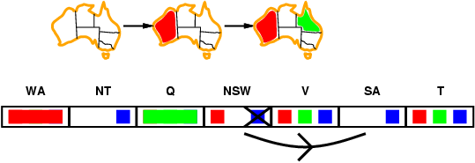 | 2 | L3 | 1 | 1 | 1.6.1
7 | Explain the problem formulation in detail.  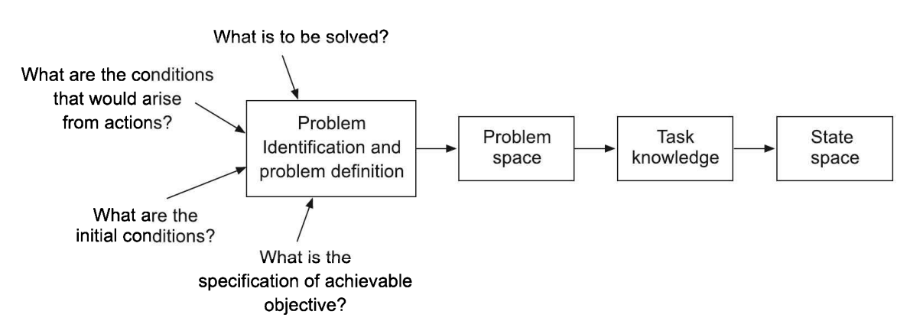 | 2 | L3 | 1 | 2 | 2.6.4
8 | In this scenario, three missionaries and three cannibals must cross a river using a boat that can carry at most two people at a time. However, if at any point the number of cannibals on either bank of the river exceeds the number of missionaries, the cannibals will outnumber and eat the missionaries. The goal is to safely transport all missionaries and cannibals from one side of the river to the other, adhering to these constraints. Discuss how you would approach representing the problem, generating and evaluating possible moves, and ensuring that all solutions are valid and safe. Consider methods for efficiently exploring the search space, pruning invalid states, and identifying optimal sequences of actions to reach the goal state.  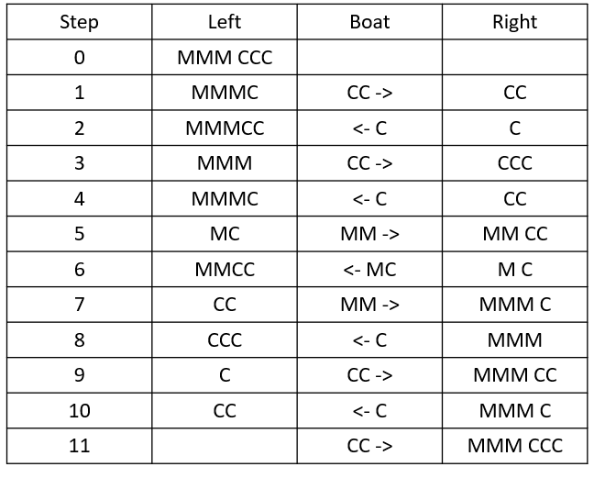 | 2 | L3 | 1 | 1 | 1.6.1
Part – C (1 x 10 = 10 Marks)
9 | You're leading a team developing an AI algorithm to solve cryptarithmetic problems, specifically focusing on puzzles where letters represent digits and addition operations need to be deciphered. One such puzzle involves the equationto find the value of ORANGE, when BANANA + GUAVA = ORANGE, where each letter represents a unique digit from 0 to 9. The task is to find the corresponding digit for each letter to make the equation valid. The team aims to create an efficient solver capable of handling various cryptarithmetic puzzles with minimal computational resources.  2 4 9 4 9 4  6 5 4 7 4  ---------------  3 1 4 9 6 8  O = 3, R = 1, A = 4, N = 9, G = 6, E = 8.  So the answer is 31. | 2 | L4 | 1 | 1 | 1.7.1
10 | Describe how the washing machine exemplifies the concepts of agents, intelligent agents, and rational agents. Discuss the components and functionalities that enable the washing machine to function as an agent, its ability to make intelligent decisions based on sensory inputs and learning capabilities, and how it demonstrates rational decision-making to optimize utility or user satisfaction. Provide examples to illustrate each aspect and explain how they collectively contribute to the washing machine's effectiveness in performing laundry tasks efficiently and intelligently.  P: Cleanliness of clothes, time taken, electricity consumed, water used, detergent used, noise made  E: Clothes, water tap, water, detergent  A: Motor rotating the drum/ spindle, time indicator, operation completion alarm  S: Water level sensor, detergent sensor, cloth weight sensor, time clock. | 2 | L4 | 1 | 2 | 2.6.4

*Program Indicators are available separately for Computer Science and Engineering in AICTE examination reforms policy.

Course Outcome (CO) and Bloom’s level (BL) Coverage in Questions

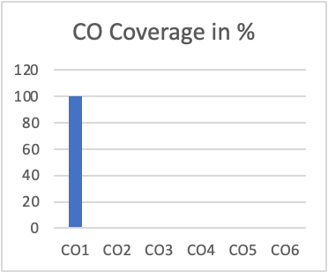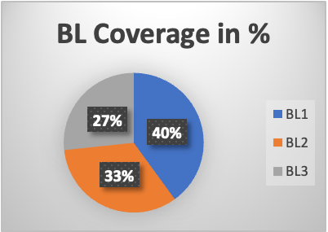

Approved by the Audit Professor/Course Coordinator

